Group report -rule-based vs llms
introduction

in this axis of rule-based approaches versus LLMs， we have chosen the Regular Expressions （Regex）as the main rule-based approach, and a generative fine-tuned language model, Qwen3-0.6B, as the primary large language model to compare their performance in clinical abstracts extraction. Rule-based approaches rely on the special patterns between lexical structures without understanding underlying semantic context. Considering the complexity of clinical trial abstracts, we hypothesize Regex can provide relatively reliable precision (Precision) because strict lexical constraints but performs a low recall as it cannot generalize to medical terminology and diverse lexical variation.so improve the performance along this axis, I designed a extraction pipeline based on Qwen3-0.6B. The core methodology utilizes the few-shot prompting in-context learning strategy to convert the target extraction fields (such as the conditions and sample size when extracting participants category) into natural language prompts through reliable examples from the raw text. We assume that LLM enables to significantly improve the recall of the model through its robust contextual reasoning ability.

evaluation

For this axis, we discarded the traditional strict exact span matching and chose overlap-based matching as a unified comparison metric.This is because, during the experiment period, we designed a strict window-sliding alignment algorithm to evaluate performance. However, the result yielded a zero score for the LLM. To be more specific,
models prioritize semantic matching, consequently failing to achieve absolute consistency at the string level. Whereas, traditional strict matching heavily penalizes subtle variations in word boundaries, which completely ignore the real semantic extraction ability of generative models.
So we adopted the overlap-based metric as our main evaluation method. Specifically, if a predicted token appears within the benchmark (gold-standard) span (p_token in t), it is counted as a successful extraction. Although this effectively avoids the misjudgment of LLMs, it may cause false positives when the system extracts general phrases, which trigger a large number of unexpected matches in the full text
Regarding the experimental setup, the regular expression rules were primarily designed based on an explicit analysis of A portion of the training split though radom sample and implemented via Python’s re library. In contrast, through the AutoModelForCausalLM class from the Transformers library, the generative pipeline using the Qwen3-0.6B model relied solely on few-shot prompts derived from the same training split. Finally, both methods were evaluated on the entirety of the test dataset.

The design of the Regex mainly refers https://www.whatsmyip.org/regular-expression-
tester/
https://huggingface.co/Qwen/Qwen3-0.6B

results
rule-based
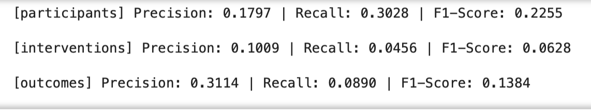

Llms
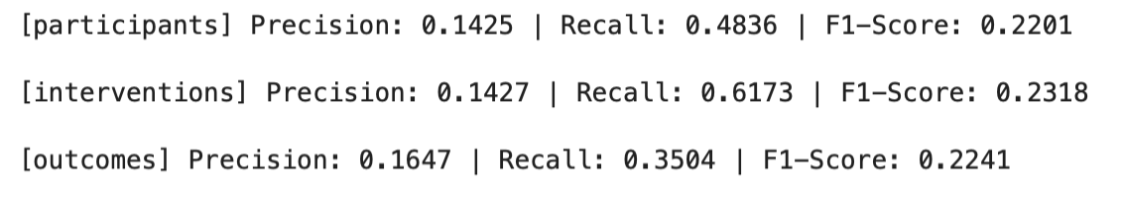
As shown in Table 1 and Table 2, the Regex approach performed a low recall across all categories (only 0.0456 for Interventions). Consistent with our hypothesis, the recall rate across all categories achieved great improvement (the recall rate of interventions increased from 0.0456 to 0.6173) when using the the Qwen3-0.6B model. This strongly proves that LLMs can identify complex semantic patterns while the Regex can provide a special lexical matching.

d) errors analysis
According to the final performance test results, the recall across all categories is significantly low (0.1797 for Participants and 0.1009 for Interventions) This is because the inherent limitations of manually defined regular expressions in facing complex lexical contexts. By analysing the missing spans that have not been successfully extracted (false negatives), we observe that strict token-matching is at a loss when facing complex sentence structures
For example, in the Participants category, the regular rule we designed \d+\s+\b(?:patients|men|women|males? |females?) \b aims to capture the sample size and characteristics of the participants (e.g. '245 patients'). However, it is completely unable to capture long descriptive fragments, such as: "Forty-three chronic stroke patients with mild to moderate upper extremity Impairment". The reason why the rule is invalid here is that it strictly matches the Arabic numerals (\d+) rather than the spelled numeral words ("Forty-three"); in addition, it cannot deal with the modifiers inserted between the number and the target participants ("chronic Stroke").
Therefore, although the strict constraints of regular expressions ensure a high precision, a large number Of false negatives produced as their inability to Identify the diversified vocabulary and syntactic patterns in medical texts, seriously affecting the overall recall rate of the system.

e) discussion

The primary advantage of Regex is its explicit interpretability. This means it is easy to find identify and correct faulty rules when occurring errors. However, it performs limited flexibility because the clinical corpus inherently contain complex semantic structures and abundant lexical words. While the LLM present an effective ability to bridge this generalization gap, the relatively lower precision remains a concern.
Therefore, it is possible method to construct a pipeline combines the high recall of LLMs with the strict precision of rule-based approaches for the real-world clinical abstract extraction.

